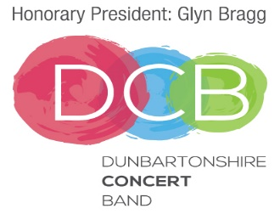

Consent to Emergency Medical Treatment

The Dunbartonshire Concert Band has my permission to obtain emergency
medical treatment for my child___________________________________,
if I cannot be reached, or if, a delay in reaching my child would be dangerous for him or her.

Parent/Guardian’s Name: __________________________________________

Home Tel No: ______________________ Mob Tel No: ___________________

Email Address: ____________________________________________________

Existing Medical Conditions: ________________________________________

My child is taking the following medications: ____________________________

My child is allergic to the following medications_________________________

My child has the following allergies: ___________________________________
Any other information we should be aware of:

Signature of Parent/Guardian: _______________________________________

Date: ____________________________________

You are required to advise the Secretary of the Dunbartonshire Concert Band of any changes to the information provided.

