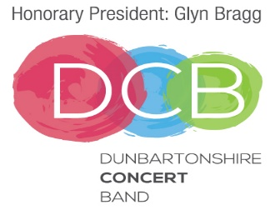

Child Photo/Video
CONSENT FORM

To comply with the Data Protection Act 1998, we need your permission before we can photograph or make any recordings of your child.

PLEASE RETURN THE COMPLETED FORM TO THE CHAIR OR SECRETARY OF THE DUNBARTONSHIRE CONCERT BAND.

I give: The Dunbartonshire Concert Band or DCB Committee
or the following Named Person: _____________________________________

Permission to take photographs/videos of my child.

I Grant: The Dunbartonshire Concert Band or DCB Committee
or the following Named Person ______________________________________

Full rights to use the images resulting from the photography/video filming, and any reproductions or adaptations of the images for fundraising, publicity or other purposes to help achieve the Dunbartonshire Concert Band’s aims. This might include, but is not limited to, the right to use them in their printed and online publicity, social media, press releases and funding applications.

Name of Child
Name of Parent/Guardian
Signature of Parent/Guardian
Date

It is your responsibility to let us know if you want to withdraw or change your agreement at any time.

