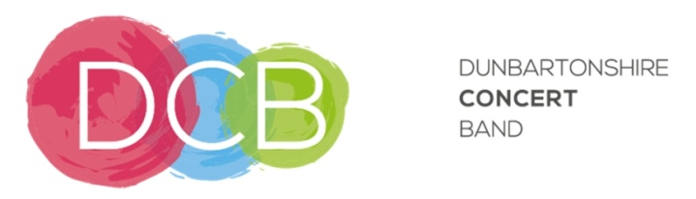

Membership Form and Gift Aid Declaration
for annual subscriptions and donations

Dunbartonshire Concert Band Registered Charity: SC011887

Please treat as Gift Aid donations all qualifying gifts of money made
today in the past 4 years in the future

Please tick all boxes you wish to apply.
I confirm I have paid or will pay an amount of Income Tax and/or Capital Gains Tax for each tax year (6 April to 5 April) that is at least equal to the amount of tax that all the Charities or Community Amateur Sports Clubs (CASCs) that I donate to will reclaim on my gifts for that tax year. I understand that it is my responsibility to pay the difference if I pay less tax in any year. I understand the charity will reclaim 25p of tax on every £1 that I give each year.

Donor’s details

Title: Contact phone no:
First name or initial(s):
Surname:
Full home address:
Postcode:
Instrument(s):
Date:
Signature:

Please notify the DCB Treasurer if you:

- Want to cancel this declaration
- Change your name or home address
- No longer pay sufficient tax on your income and/or capital gains.

If you pay Income Tax at the higher or additional rate and want to receive the additional tax relief due to you, you must include all your Gift Aid donations on your Self-Assessment tax return or ask HM Revenue and Customs to adjust your tax code.

In completing this form, you agree to your personal details being retained by DCB treasurer and secretary and managed in compliance with the Data Protection Act.

